The story of stuff and the circular economy

First of all, there's a lesson from the live you got it which is any action has repercussions and that same in business. Business throw all the process that get a product in the end, we should know that stuff got a lifecycle in other word called **material economy** and that lifecycle is linear which is in the end of the process it's will be exposed instead of this we could have the advantages of it by converting it to cycle system and that exactly **circular economy.**

the whole process start fromresources or raw materials that start from. And those material got extract from the natural resources, which is already start decrease in massive way, and accompany with that pollution and killing manifestations of life by nature.

Then we move to the factory that make the products from the raw Materials, that may use a toxic substance in the manufacturing process that would make the air pollution, the worker whom extract the natural resources they move to the factories to work after they used all natural resources so the human work along all the process, more manufacturing means more pollution also more consuming of resources.

The goods transfer from the factors to the market to be in front the sight and the hand of the user after the user see it purchase it.

Let's move to the final place for those stuff it's the disposal where we even burn or bury the waste in the ground and all that will effect on the air, soil and water we can't discard the climate changes.

The amount of resources the planet can replenish is almost two times what we utilize.

**Some information about the process:**

But we got the people that work along all the process in addition the government that we're the high priority to them to take care of us as a community but that priority changed because of the corporate and the growth that makes them the high priority of the government. Even the people is in danger of cancer and poisoning of the toxic substance which that factor deal with, in Congo 30 % to mining Colton. So we didn't think this stuff how struggling of all the people and environment to be in my hand.

**The shocking fact** is the 99% of the stuff we buy and we become a consumer because of it we throw it in garbage in just first 6 months of using it. The corporate follows a strategy to make that product an old as quick as possible to keep consuming flow more and more and that doesn't make the happiness scale increasing It's the opposite.

**negative externality**

An economic term known as a "negative externality" describes the unexpected consequences or expenses that are incurred by a third party as a result of the creation or consumption of products or services. It has a detrimental effect on people or groups that are not directly participating in the economic activity, to put it another way.

So what's the solution of all that? The effective solution we got is the recycling and it could be in all stages in the process and that make the differences come up faster or at least in disposal of the material economy in less extent.

**In my point of view:**

The mindless consumption it's a new challenge to the world so have your need not more than otherwise the consequences are dire. In the result you're just using the natural resources and consume it at the end we have one planet. So we must use the resources careful and recycle it to reuse it.

I do a test for identifying the ecological footprint it was shocked to have 3.3 earth if all the humanity wants to live as my lifestyle. I didn't that impact on the environment, so that push me to use renewable resources and recycle my unused stuff.

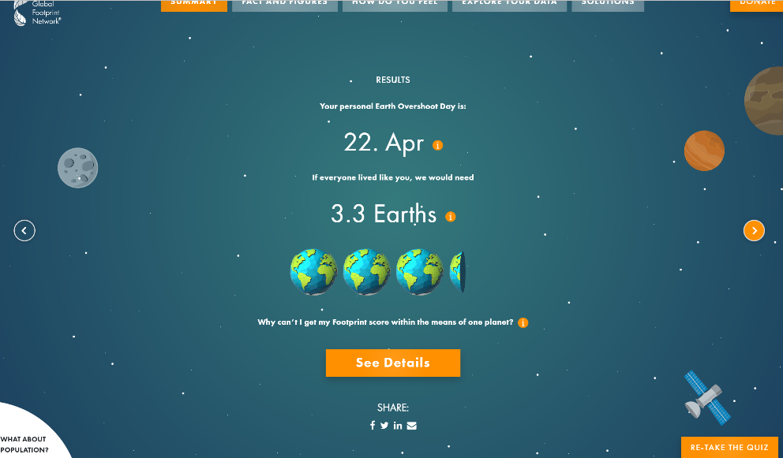

I can compare the circular economy like the lifecycle of the water which is a natural process of the water that fail from the clouds to the rivers and seas then to evaporates the water after that water condenses in clouds so the circular economy must be in a close circle of operation to keep our planet safe without drain the resources of the planet from the extracting the resources after the use and use the useless to be a row material to keep looping without need new resources.